Melody Lamphear

Kickstarter project analysis takeaways:

1. What are three conclusions we can make about Kickstarter campaigns given the provided data?

* The overall success rate for all projects in this data set is 53%, and the failed rate is only 37%. This suggests that the projects in this sample may provide examples of what is required to succeed in Kickstarter. The most popular categories in the sample are Theater and Music and both have the highest success rates:

Success rate by category:

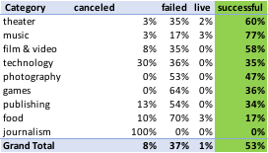

Outcome by category:



* Journalism and food categories seem to have the least chance of success:
  + 100% of all journalism projects were canceled, indicating that there is a low confidence level that these kinds of projects will be funded
  + Within food projects, 86% of food truck projects failed, and the balance were canceled.

1. What are some of the limitations of this dataset?

* The data could be skewed by the fact that the categories with the most projects have the highest chances of success, showing bias driven by the size of the sample.

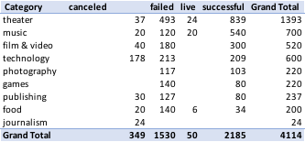

* Within the Theater category, those with the greater record of success are Plays, which were the most common:

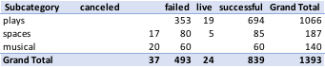



1. What are some other possible tables/graphs that we could create?

* To understand the data, we should review tables that show percentage of total by country and notice that the majority of the projects are based in the US, so filtering by country may not be necessary throughout the analysis:



* Dissecting the data by goal $ size shows that 51% of projects have goals of under $10K:

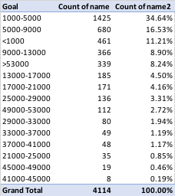

* To understand the goal sizes for those projects that show high failure/cancel rates we need to create an additional table showing subcategory, name and goal size by project. For example, all journalism projects were canceled, begging the question of what drives the lack of confidence in this kind of project. One potential answer is that the cost may be too high, compared to the $5K-$10K average goal seen in other more successful projects:

